**Supplementary Report SRPP No: 2018STH025**

|  |  |
| --- | --- |
| **SUPPLEMENTARY MEMO SRPP No** | **2018STH026** |
| DA Number | DA0331/2018 |
| Local Government Area | Shellharbour |
| Proposed Development | Staged subdivision of Lot 4003, DP 1235539 into 59 Lots comprising of 42 Housing Lots, 2 Public Reserve Lots, 9 Future Residential Superlots and 6 Residential Lots. (Precincts F/G land subdivision) |
| Location | Shell Cove |
| Applicant / Owner | Australand Corporation (NSW) Pty Ltd (Frasers Property) / Shellharbour City Council |
| Recommendation | That SRPP No. 2018STH026 (DA0331/2018) be approved subject to the schedule of conditions contained in Attachment 1 of the SRPP No. 2018STH026 (DA No. 0331/2018) Planning Assessment Report dated 12 November 2018. |
| Memo prepared by | Madeline Cartwright – Senior Development Assessment Officer  Madeline Cartwright signature |
| Date of report | 18 December 2019 |
| Endorsed  Grant Meredith – Group Manager – City Development |  |

**Purpose of Supplementary Report**

The purpose of this report is to respond to the queries raised by the Southern Regional Planning Panel (the Panel) via emails dated 17/12/2019 and 18/12/2019 as follows;

1. The Panel noted an error included in the Council assessment of DA0331/2018, SRPP No. 2018STH026 relating to suitably addressing State Environmental Planning Policy Coastal Management 2018 (SEPP CM 2018). This supplementary report has been submitted to address this previous error and fully address the requirements of SEPP CM 2018,
2. The Panel have requested a review of the wording of proposed condition 30 relating to Acid Sulfate Soils,
3. Confirmation required that the proposal is a staged DA and that Stage 2 is to be the subject of another DA because of the remediation or is the development just being developed in 2 stages.
4. Has Council assessed with cross sections submitted and found the land relationship to be acceptable?
5. **State Environmental Planning Policy Coastal Management 2018**

The original assessment report submitted to the Panel wrongly stated that the DA was lodged prior to the commencement of State Environmental Planning Policy Coastal Management 2018 (SEPP CM 2018). The DA was lodged on the 5 July 2018 and SEPP CM 2018 commenced on the 3 April 2018, therefore SEPP CM 2018 should have been addressed.

The aim of SEPP CM 2018 is to promote an integrated and co-ordinated approach to land use planning in the coastal zone in a manner consistent with the objects of the [*Coastal Management Act 2016*](https://www.legislation.nsw.gov.au/#/view/act/2016/20), including the management objectives for each coastal management area.

The site falls within the coastal zone as identified by the SEPP CM 2018 online mapping system. The subject site of lots 4003 DP1235539 include land within the Coastal Use area, as shown in figure 1 below, the Coastal Use Area is shown in peach colour. Consequently, Division 4 and 5 applies to the subject proposal.

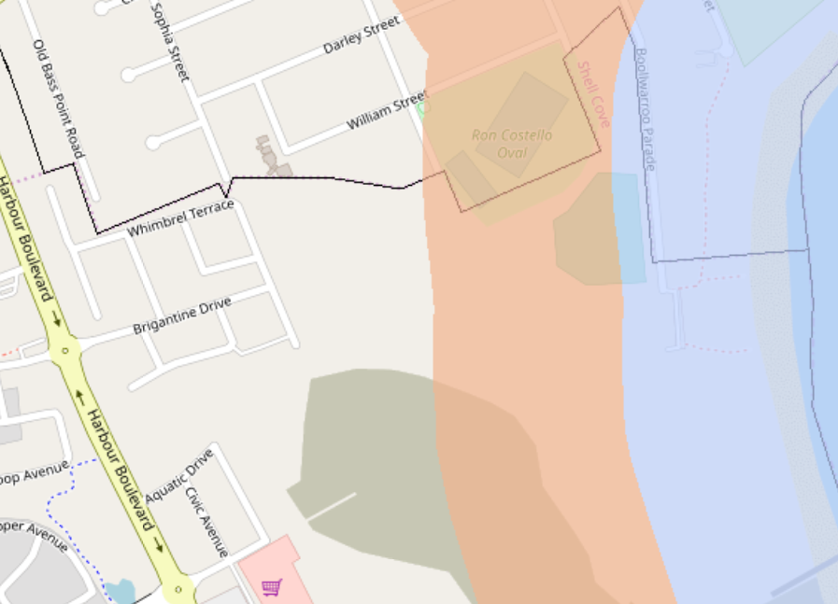

Figure 1 - SEPP CM 2018 Map Extract

Pursuant to Division 4 the subdivision includes land which extends down to the marina water edge, this is considered to be a foreshore for the purposes of assessment against the considerations of SEPP CM 2018, the site is approximately 240 metres from the Crown Foreshore Land adjacent to the Pacific Ocean.

Division 4 Coastal Use Area

14 Development on land within the coastal use area

1. (a)
2. The proposed subdivision will not cause adverse impact on existing, safe access to and along the foreshore of the Marina. In accordance with the Shell Cove Concept Approval MP07_0027 MOD 1 a public walkway will be constructed along the entire foreshore of the Marina to allow public access. This walkway is subject of a separate DA (DA0400/2019) which is currently being assessed by Council. The proposed subdivision has been designed in conjunction with this walkway and does not impede the route around the Marina. Public access to the beach, headland or rock platform for members of the public will not be impacted by the proposed subdivision.
3. The proposed subdivision will not result in any overshadowing, wind funnelling or the loss of views from public places to the Marina or Ocean foreshore. The layout is in accordance with the Concept Approval and ensures that the public spaces have uninterrupted views of the water. Figure 2 below includes the proposed overall plan currently under assessment for DA0400/2019 for information.

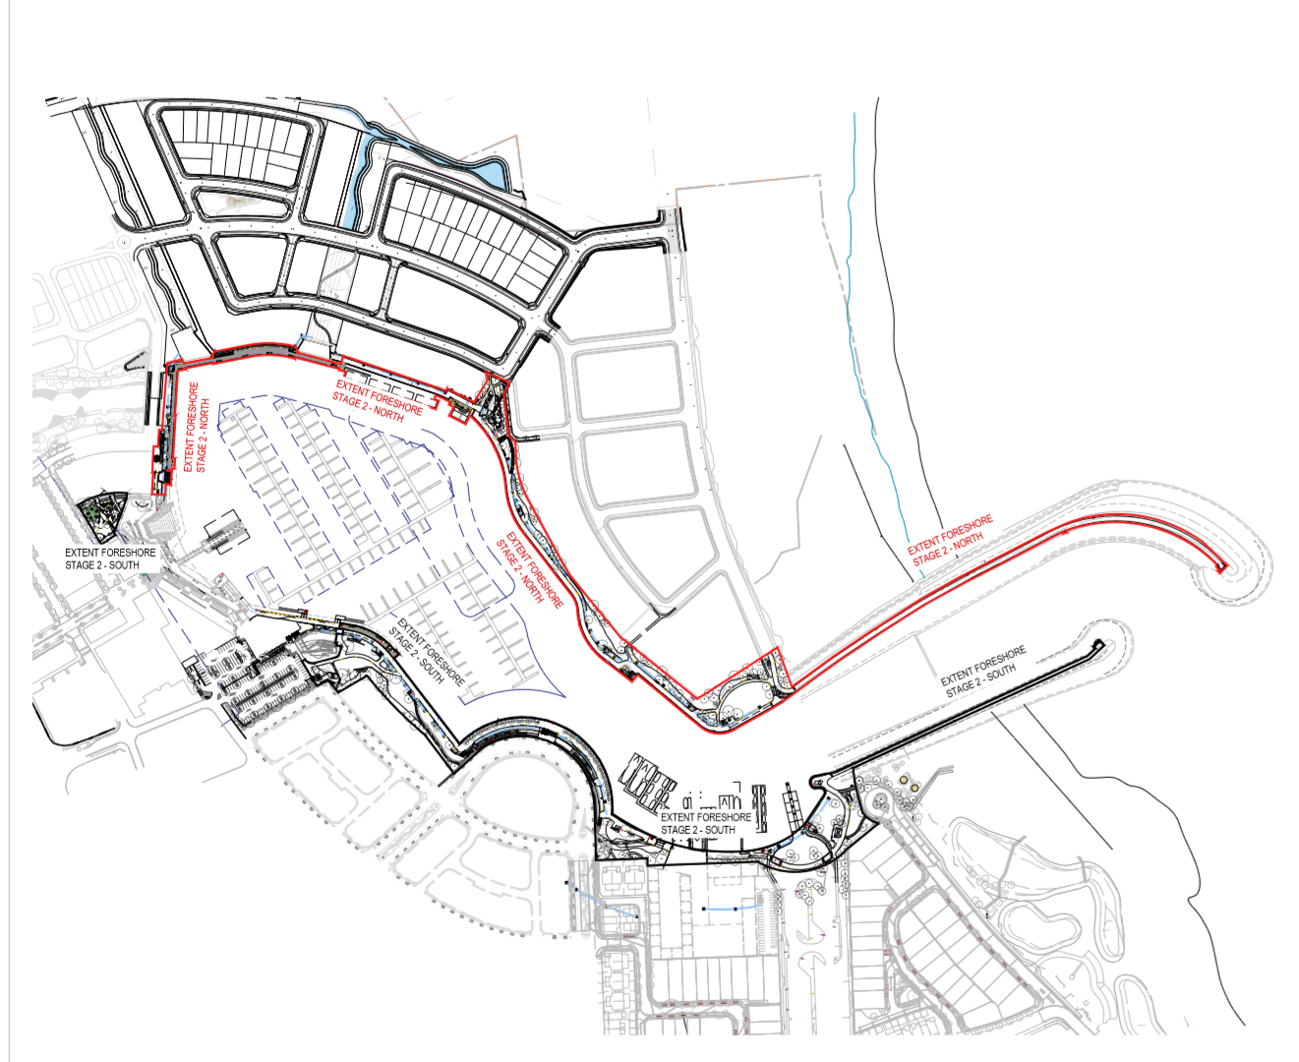

Figure 2 - Proposed layout plan DA0400/2019 - Marina Foreshore works (north)

1. The visual amenity and scenic qualities of the coast, including coastal headland have been considered and are not adversely affected by the proposed subdivision.
2. The proposed development is not considered to have an adverse impact on the Aboriginal cultural heritage, practices and places. A Cultural Heritage Review was submitted as part of the Concept Approval which found that there were no indigenous sites within the wider Shell Cove Boat Harbour Precinct Area, the study also concluded that the Boat Harbour site as a whole had low archaeological sensitivity. Registered Aboriginal objects/sites are known within the wider area but these are not in proximity to the application site.
3. The proposed subdivision is not considered to have an adverse impact on the cultural and built environment heritage. The Cultural Heritage Review as submitted as approved as part of the Concept Approval found that there were no European Heritage elements within the lands included in the Concept Approval.

1)(b)

(i) Council is satisfied that the proposed subdivision is designed, sited and will be managed to avoid an adverse impact on the areas detailed in (a) (i). The siting of the proposed subdivision is in accordance with the approved Concept Plan and public access to the Marina Foreshore will be managed by Council.

1)(c) Council has taken into account the surrounding coastal and built environment in the assessment of this proposed subdivision. The proposed subdivision does not include development beyond the construction of roads and associated drainage.

Division 5 General

The proposed subdivision is not considered to increase the risk of coastal hazards and no certified coastal management programmes apply to the subject site.

Conclusion

Pursuant to Division 4 and Division 5 of the SEPP CM 2018 Council is satisfied that the relevant policy matters have been considered and that the proposed subdivision will not have an adverse impact on the coastal area.

1. **Review of Condition 30 – Acid Sulfate Soils**

The Panel have noted that condition 30 reads as a series of notes rather than a requirement, the current condition is included as figure 3 below;

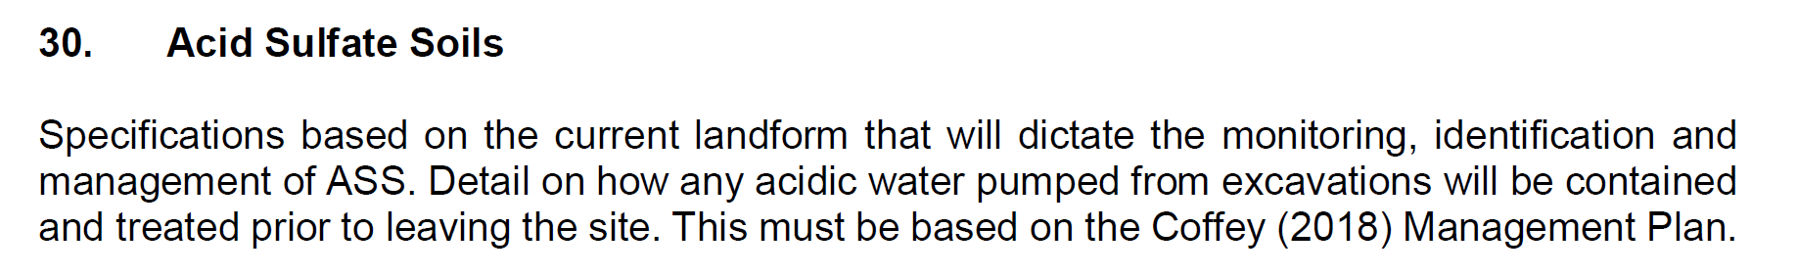

Figure 3 - Condition 30

Council has reviewed the proposed condition and has re-worded as follows;

**30. Acid Sulfate Soils**

Prior to the issue of a Construction Certificate details of how acidic water pumped from excavations will be contained and treated prior to leaving the site must be submitted to Council for approval. These details must be based on the approved Acid Sulfate Soil Management Plan Precinct F & G Shell Cove reference WOLEN209869-R01 by Coffey Geotechnics Pty Ltd dated 28 /02/2018.

1. **Confirmation of how proposed development is to be staged**

Stage 2 of the proposed development relates to the management of the triangular lot within Precinct G only which is contaminated land (asbestos). Figure 4 below includes a site plan to give an indication of the triangular piece of land referred to. Please note that conditions 104 – 109 inclusive relate to the trigger for submission for the DA for Stage 2, the trigger is the DA for stage 2 must be lodged prior to the issue of the subdivision certificate for stage 1.

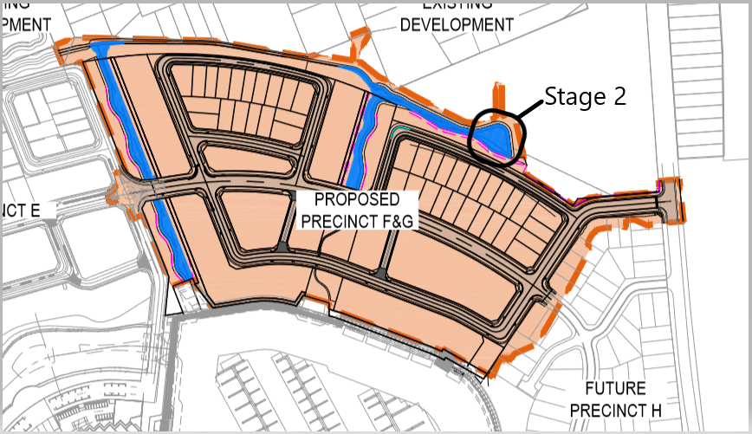

Figure 4 - Stage 2 land

1. **Council’s assessment of the Cross Sections**

The cross sections submitted to the Panel as part of Supplementary Report dated 11 December 2019, have been assessed by Council. In relation to access for maintenance, amenity, ownership and general urban design the cross sections were considered satisfactory. The interface between the proposed subdivision site and the existing residential development on the northern edge of the site has specifically been considered at the Panel’s request and Council are satisfied with the information receved.

1. **Recommendation**

That conditional development consent is granted to SRPP No. 2018STH026 (DA No. 331/2018) for the subdivision of Land to create Two Stage Subdiviion of Lot 4003, DP1235539 into 57 Lots comprising of 42 Housing Lots, Five Public Reserve Lots, Nine Future Residential Superlots and One Residue Lot (Precincts F/G land subdivision) at Lot 4003, DP1235539, Old Bass Point Road, Shell Cove for the following reasons:

1. The subdivision development is in the public interest for the reasons provided in 4.1.9 Section 4.15(1)(e) – the public interest of the Council Planning assessment report dated 12 November 2019, Supplementary Report dated 11 December 2019 and this supplementary report, and
2. The proposal is generally consistent with the terms of the approval of the concept plan MP07_0027 as modified by MOD 1 and Statement of Commitments schedule.

**Attachment 1 – Schedule of draft conditions**

This development consent has been divided into different parts according to where, during the development process, each condition may be most relevant. Some conditions may be appropriate to more than one part. All conditions must be complied with.

1. **Staging of Development**

The development shall be staged as follows, unless otherwise approved by Council in writing:

**Stage 1** – Bulk Earthworks and Subdivision works across both Precincts F & G including construction stages 1 to 6.

**Stage 2** – Management of Triangular Lot to Precinct G (contaminated land section – asbestos).

All relevant conditions of this consent apply to each stage, unless otherwise specified. In this case, the development application for the management of contaminated land has been included in a separate stage (7).

Each stage must not be occupied or used until the Principal Certifying Authority issues an Occupation Certificate for that stage.

**PART A - ADMINISTRATIVE CONDITIONS**

* 1. **Construction Certificate (Subdivision) & PCA Notification Environmental Planning & Assessment Act 1979**

Before any site works, building or use is commenced, the person having the benefit of the development consent must:

1. obtain a Construction Certificate from Shellharbour City Council or other accredited certifier; and
2. appoint a Principal Certifying Authority.

For Torrens Title Subdivision, the appointed Principal Certifying Authority must be Shellharbour City Council.

* 1. **Prescribed Conditions**

This development consent is subject to the prescribed conditions made under the Environmental Planning & Assessment Regulation 2000.

* 1. **Development in Accordance with Plans**

The development must be in accordance with the following approved Development Application plans and documents as endorsed by Council's stamp except where modified by conditions of this consent. Where there is an inconsistency between the approved plans/documentation and the conditions of this consent, the conditions will take precedence to the extent of the inconsistency.

| **Name of Plan/Document** | **Prepared By** | **Reference** | **Date** |
| --- | --- | --- | --- |
| Cover Sheet And Drawing List | Arcadis | C-FG-001 (Rev 2) | 13.06.20189 |
| General Notes | Arcadis | C-FG-002 (Rev 2) | 13.06.2018 |
| Site Plan | Arcadis | C-FG-0003 (Rev 2) | 13.06.20189 |
| Lot Layout Plan | Arcadis | C-FG-0004 (Rev 3) | 07.02.2019 |
| General Arrangement Plan | Arcadis | C-FG-0005 (Rev 3) | 07.02.2019 |
| Typical Road Cross Sections | Arcadis | C-FG-0006 (Rev 3) | 07.03.2019 |
| Typical Details | Arcadis | C-FG-0007 (Rev 2) | 13.06.2018 |
| Staging Plans | Frasers | SK01 (P1) - SK06 (P1);  Stages 1-6 | 11.07.2019 |
| Plan of Subdivision | Beveridge Williams | Pages 1- 2 of 2 – Stage 2 | 20.09.2019 |
| (preliminary plans)- | (Rev C) |
| Hannah Martin (Surveyor- Ref - 1601522-FG-6 | Pages 1-2 of 2 – Stage 3 (Rev C) |
| Pages 1 of 1 – Stage 4 (Rev |
| C) |
| Pages 1 of 1 – Stage 5 (Rev |
| C) |
| Pages 1 of 1 – Stage 6 (Rev |
| C) |
| Landscape Plans | Group GSA | L-PE1 -000- Cover sheet (Rev C) | 30.05.2018 |
| L-PE1 -2000- Planting Schedule (Rev A) | 30.05.2018 |
| L-PE1 -2001-General Arrangement Plan (Rev C) | 30.07.2018 |
| L-PE1 -4001-Engineers sections (Rev B) | 30.05.2018 |
| L-PE1 -4002-Engineers sections (Rev B) | 30.05.2018 |
| L-PE1 -4003-Landscape Details (Rev A) | 30.05.2018 |
| L-PE1 -4004-Landscape Details (Rev D) | 30.07.2018 |
| Utilities Strategy | Arcadis | Utilities Strategy | 17.05.2018 |
| Shell Cove Precinct F and G Stormwater and Water Cycle Management Plan | Advisian | 2018- Ref: 301015-03163 | 25.06.2018 |
| Acid Sulfate Soil Management Plan Precinct F&G Shell Cove | Coffey Geotechnics Pty Ltd | WOLEN209869-R01 | 28.02.2018 |
| Traffic Impact Assessment – Shell Cove Precinct F,G and Wetland 8 | Arcadis | AA006310 (Rev D) | 12.06.2018 |
| Earthworks Strategy, Road Design, Acid Sulphate Soil (ASS) & Erosion and Sediment Control Report | Arcadis | AA006310-FG-01 (Rev 03) | 28.10.2019 |

* 1. **Compliance with Notations on Drawings**

Works must comply with any annotations on the approved plans.

* 1. **Street Numbering**

Location points for mail delivery must satisfy the requirements of Australia Post. Street numbers must be obtained from Council’s GIS Department during normal office hours, and clearly displayed on the premises, prior to the issue of an Occupation Certificate.

Addresses should be included on the subdivision plans and noted on the Subdivision admin sheet. Please ensure Lot numbers on the Subdivision plan are the same as Unit & house numbers on DA & construction plans.

**PART B - PRIOR TO ISSUE OF SUBDIVISION CONSTRUCTION CERTIFICATE**

* 1. **Culvert Design**

Exclusion bars or inlet/outlet screens may be required over the inlet to the major culverts draining the Eastern Overland Flow Channel to prevent people (adults and children) from potentially being washed into the culverts during times of high flow. A risk assessment carried out in accordance with the procedures in the Queensland Urban Design Manual (QUDM) is to be submitted with design and supporting calculations to the satisfaction of the PCA prior to issue of a construction certificate.

* 1. **Wetland and Water Quality Management**

Draft Wetland Management, Operation, Maintenance and Monitoring Manual/s ('Manuals') for the permanent water quality facility shall be provided for approval to the Principal Certifying Authority. The Manuals shall be prepared by a suitably qualified person in accordance with Council's Engineering Specifications and water quality objectives.

* 1. **Flow Velocity in Vegetated Stormwater treatment areas**

All Vegetated Stormwater Systems including constructed wetlands and bioretention systems are to be designed and located such that velocity of flows travelling through areas containing macrophytes are less than 0.5 m/sec in all design events up to and including the 10% AEP and less than 2 m/sec for all remaining events up to and including the 1% AEP. Details supporting this must be submitted to the satisfaction of the Principal Certifying Authority.

* 1. **Water Sensitive Urban Design Checklists**

Compliance checklists are to be prepared by the Constructed Wetland Designers and submitted to Council prior to issue of a construction certificate. The checklists must incorporate all checks and certifications that are required to be carried out during the civil construction phase, asset protection phase, landscape practical completion phase and final compliance inspection prior to final handover.

* 1. **Inter-Allotment drainage**

Inter-allotment drainage must be provided to dispose of stormwater from those allotments that do not have fall to the street to which the lot fronts.

* 1. **Soil and Water Management Plan (SWMP)**

Prior to the issue of the Construction Certificate, the applicant must submit to and obtain the Certifying Authority approval of a Soil and Water Management Plan.

The SWMP must clearly identify site features, constraints and soil types together with the nature of the proposed land disturbing activities and also specifies the type and location of erosion and sediment control measures. In addition, rehabilitation techniques that are necessary to deal with such activities should be referred to.

The SWMP must take into account the requirements of Landcom’s publication Managing Urban Stormwater - Soils and Construction (2004) thus ensuring the following objectives are achieved, namely:

1. minimise the area of soils exposed at any one time;
2. conserve topsoil for reuse on site;
3. identify and protect proposed stockpile locations;
4. preserve existing vegetation and identify revegetation techniques and materials;
5. control surface water flows through the development construction site on a manner that:
   1. diverts clean run-off around disturbed areas;
   2. minimises slope gradient and flow distance within disturbed areas;
   3. ensures surface run-off occurs at non-erodible velocities; and
   4. ensures disturbed areas are promptly rehabilitated.
6. trap sediment on site to prevent off site damage. Hay bales are not to be used as sediment control devices. To ensure regular monitoring and maintenance of erosion and sediment control measures and rehabilitation works until the site is stabilized (includes landscaping);
7. specifies measures to control dust generated as a result of construction activities on site;
8. temporary sediment ponds must be fenced where the batter slope exceeds 1 vertical to 5 horizontal;
9. design scour protection for the 10 year ARI event at all inlet and outlet structures; and
10. including measures to prevent the tracking of sediment off the site.
    1. **Long Service Levy**

The Long Service Levy must be paid prior to the issue of the Construction Certificate.

* 1. **Initial Geotechnical Report**

A geotechnical report, prepared by a suitably qualified and experienced geotechnical engineer must be submitted to the Certifying Authority for approval prior to the issue of the Construction Certificate.

The report must cover, but not be limited to the following:

1. extent and stability of proposed embankments including those acting as retarding basins;
2. recommended Geotechnical testing requirements;
3. level of geotechnical supervision for each part of the works as defined under AS 3798 - Guidelines on Earthworks for Commercial and Residential Developments;
4. an analysis of the level of risk to existing adjacent structures/buildings including the scenario of a construction contractor using vibratory rollers anywhere within the site the subject of these works. In the event that vibratory rollers could affect adjacent structures/buildings, high risk areas must be identified on a plan and indicate that no vibratory rollers shall be used within that zone;
5. the impact of the installation of services on overall site stability and recommendations on short term drainage methods, shoring requirements and other remedial measures that may be appropriate during installation;
6. the recommended treatment of any unstable areas within privately owned allotments;
7. requirement for subsurface drainage lines; and
8. overall assessment of the engineering plans for the proposed development and their suitability in relation to the site's geotechnical characteristics.
   1. **Road Design**

The road design must comply with the following:

1. the grading and layout of all roads and lots must not allow for trapped low points and in addition ensure that overland flow is passed safely over public land;
2. the road pavement must be designed with one layer of asphalt having a minimum thickness of 40 mm AC 10, except where pavers have been detailed in the DA plans. The pavement design for the proposed roads must be carried out by a qualified Geotechnical/Civil engineer in accordance with AUSTROADS Guide to Pavement Technology;
3. all vertical and horizontal alignment of all streets and all street intersections within the development must have adequate sight distance provided in accordance with AUSTROADS requirements;
4. the geometric design of all roads, traffic facilities, intersection treatments, mid-block devices and entry features must be such as to permit a 12.5m rigid vehicle to manoeuvre in order to enter and leave each road travelling in a forward direction and without leaving the carriageway; and
5. the relevant drawings must be annotated and properly referenced showing compliance with this condition. The drawings must be submitted with application for a Construction Certificate for approval by the Certifying Authority.
   1. **Soil and Water Management Plan (SWMP) Bond**

The developer must lodge a bond to the amount of $200 per lot to ensure compliance with erosion and sediment control measures incorporated in the approved Soil and Water Management Plan (SWMP). This bond must be in the form of an irrevocable bank guarantee made out in favour of Council, and must operate as follows:

1. the bond must be submitted to Council prior to the release of the engineering plans for the subdivision;
2. the bond must be held by Council until the expiration of the defects liability period for the subdivision, which commences at the completion of all engineering works, including placement of the final seal on all new roads; and
3. if Council is to advise the developer that maintenance work is required on the erosion and sediment control measures, remedial work must be substantially commenced within forty eight (48) hours from the time of advice. Failure to comply with this direction will give Council the right to employ an appropriate contractor (which could include the Soil Conservation Service) to undertake such measures as deemed necessary and fund these works from the bond guarantee.
   1. **Road and Drainage Plans**

Road and drainage plans, must be prepared by a suitably qualified Engineer, in accordance with Council's Subdivision Design Code. The plans must be submitted to the Certifying Authority for approval prior to the release of the Subdivision Construction Certificate. All road and drainage work must then be constructed in accordance with Council's construction standards and approval at no cost to Council.

All stormwater pipes within the road reserves and within drainage easements intended to be dedicated to Council must be installed generally to the HS3 standard in accordance with the current edition of AS 3725 - Design for Installation of Buried Concrete Pipe.

* 1. **Stormwater Discharge to Natural Watercourse**

Stormwater discharge point to the natural watercourse must be protected against erosion. Details are to be submitted and be to the satisfaction to the Certifying Authority prior to the release of the Construction Certificate.

* 1. **Structural Design of Deep Pits**

All pits deeper than 0.9 metres must be designed by a certified structural engineer and be in accordance with AS3600-2009. Pits deeper than 1.2 metres must have galvanised steel step irons (plastic coated black steel step irons will not be accepted) and pits deeper than 1.8 metres are to be reinforced concrete. Step irons at 300mm interval spacing from bottom of pit. Top step minimum 500mm below top surface level. Details to this effect shall be incorporated on the detailed drainage design that is submitted to the Certifying Authority for the Construction Certificate.

* 1. **Retaining Walls**

All retaining walls must be designed by a practicing structural engineer. Retaining walls must be located wholly within the property, including footings and agricultural drainage lines. This may require the wall to have a boundary setback of at least 200mm. No part of a retaining wall structure is to encroach on land proposed to be dedicated to Council, except where detailed on the approved DA plans. Construction of retaining walls or associated drainage work along common boundaries must not compromise the structural integrity of any existing structures. All retaining walls must be constructed of masonry materials. Retaining wall details to be submitted with the Subdivision Construction Certificate.

* 1. **Electricity Substation**

Where required, the land owner must dedicate to the applicable energy supplier, free of cost, an area of land within the development site (excluding any approved landscaped area that form part of any obligations to deliver landscape areas) to enable an electricity substation to be installed. The size and location of the substation must be submitted for approval of both Council and the energy provider prior to the Subdivision Construction Certificate being issued.

* 1. **Landscape Inspection Fee**

The developer must lodge with Council an inspection fee of $314.00 in accordance with Council's

Fees and Charges prior to the issue of the Construction Certificate for:

* landscape inspection prior to the release of the Subdivision Certificate; and
* landscape inspection following completion of the maintenance period.
  1. **Street Tree Inspection Fee**

The developer must lodge with Council an inspection fee of $314.00 in accordance with Council's

Fees and Charges prior to the issue of the Construction Certificate for:

* street tree inspection of completed landscape works; and
* street tree inspection following completion of the maintenance period.
  1. **Street Tree Bond**

The developer is required to provide a bond to the value of the street tree landscape works.

The street tree bond will be returned following a 6-month maintenance period commencing from the date of the issue of the Practical Completion Certificate, provided the street trees remain in a satisfactory condition. In the event that any street trees are found damaged, dying or removed,

Council will have the option to retain the whole or part of the bond. The developer must notify Council for a reinspection of the street trees.

* 1. **Landscape Plan Construction Certificate Assessment – Open Space**

The developer must lodge with Council a fee as per Council's Fees and Charges for the assessment of the landscape plan prior to the issue of the Subdivision Construction Certificate.

* 1. **Landscape Plan – Open Space**

A detailed landscape plan must be lodged with Council prior to any commencement of landscape works. In this regard one hard copy and one electronic copy of the landscape plans prepared by a Landscape Architect must be submitted to the Council prior to the release of the Landscape Construction Certificate.

The landscape plan must be prepared in accordance with the Group GSA Landscape Concept Plan Drawing No. L-PFG-2001 C Dated 30/7/2019, Shellharbour DCP and Council’s Open Space, Recreation and Community Facilities Needs Study Report, Crime Prevention Through Environmental Design available from Customer Service or Council’s website.

* 1. **Street Tree Plan**

A detailed street tree plan must be lodged with Council prior to any commencement of landscape works. In this regard one hard copy and an electronic copy of the street tree plans prepared by a Landscape Architect must be submitted to the Council prior to the release of

the Subdivision Construction Certificate.

* 1. **Footpath and Sight Distance**

Footpaths are to be located in accordance with Precinct F and G Urban Design Guidelines and be constructed in accordance with Council’s specifications (where these are consistent –where not the proposal prevails). The setback of the footpath pavement to the lot boundary and road kerb must be detailed on the plans submitted with the Subdivision Construction Certificate.

* 1. **Waste Management Plan**

A Waste Management Plan for the development must be prepared in accordance with Shellharbour City Council's Shellharbour Development Control Plan and be submitted with the Subdivision Construction Certificate.

The plan must detail all waste streams and disposal methods. Any surplus excavated material from the site must be taken to an approved land fill site and must be detailed on the waste management plan. Waste streams that have reuse/recycling potential must be disposed to a reuse/recycling outlet and not be disposed as landfill. Excavated material may only be taken to another site with prior written approval of the Certifying Authority.

* 1. **Erosion and Sediment Control Plan**

An Erosion and Sediment Control Plan based on detailed design and construction staging is required prior to the issue of a Construction Certificate including:

* Installation of sediment fencing around disturbed areas, including any topsoil stockpiles;
* Installation of silt arrestors to collect site runoff and retain suspended particles;
* Placement of hay bales around and along proposed catch drains and around stormwater drainage pits; and
* Temporary sediment basins, sizing and calculations.
  1. **Acid Sulfate Soils**

Prior to the issue of a Construction Certificate details of how acidic water pumped from excavations will be contained and treated prior to leaving the site must be submitted to Council for approval. These details must be based on the approved Acid Sulfate Soil Management Plan Precinct F & G Shell Cove reference WOLEN209869-R01 by Coffey Geotechnics Pty Ltd dated 28 /02/2018.

**PART C - PRIOR TO COMMENCEMENT OF WORKS**

* 1. **Sediment and Erosion Controls**

Erosion and sediment control measures must be installed prior to the commencement of works. These measures must be in accordance with approved plans and sufficient to control sediment from leaving the site and entering downstream environments. Sediment and erosion control measures must be maintained throughout the entire construction phases of the development.

* 1. **Compliance with the Archaeological and Heritage Protection Plan for the Shell Cove Boat harbour/Marina**

This Archaeological and Heritage Protection Plan is part of the Environmental Management Plan (EMP) for the Shell Cove boat harbour/marina. It concerns the following areas of land (see Attachment 1):

* the Shell Cove Project Area in general; and

• AHIMS Sites 52-5-207, 52-5-436, 52-5-437 and 52-5-438.

The requirements of this plan must be adhered to at all times.

* 1. **Road Construction and Road Drainage Construction**

The site manager must arrange for a satisfactory inspection by Shellharbour City Council of the following works:

1. all road drainage works prior to backfilling of the work; and
2. all road construction inspections as per Council's Subdivision Design Code.
   1. **Site Meeting**

A site meeting with Council's Engineer, the applicant and the contractor must be held not less than 7 days prior to the commencement of work on site.

* 1. **Soil and Water Management Plan Implementation (SWMP)**

The measures required in the Soil and Water Management Plan approved by the Certifying Authority must be implemented prior to the commencement of works.

* 1. **Subdivision Design Code Compliance**

All works to be dedicated as a Council asset must be installed/constructed in accordance with Council's Subdivision Design Code.

* 1. **Construction Traffic Management Plan (CTMP)**

Prior to the commencement of works, a CTMP detailing vehicle routes, number of trucks, hours of operation, access arrangements, impact on pedestrians and traffic control must be submitted to and approved by the Certifying Authority.

It is the developer's responsibility to adequately inform/brief for construction workers, sub- contractors and supervisors to ensure that the Construction Traffic Management Procedures are adhered to at all times.

* 1. **Dilapidation Report**

It is the applicant’s responsibility to notify Council of any existing damage to public areas in the vicinity of the development site through the submission of a Dilapidation Report. The report must be supported with suitable photographic records. This information must be submitted to Council prior to the commencement of work.

* 1. **Disconnection of Utilities**

Contact must be made with service providers such as Sydney Water, Energy, and Telecommunication companies etc. for their approval with regard to disconnection of all services prior to the commencement of demolition works. All redundant services must be removed and site remediated at the cost of the developer.

* 1. **Site Management Plan**

Prior to the commencement of works, the applicant must submit to and obtain approval for a construction and site management plan from the Certifying Authority that clearly sets out the following:

1. what actions are proposed to ensure safe access to and from the site and what protection will be provided to the road and footpath area from building activities, crossings by heavy equipment, plant and materials delivery and static load from cranes, concrete pumps and the like;
2. the proposed method of loading and unloading excavation machines, building materials and formwork within the site;
3. the proposed areas within the site to be used for the storage of excavated material, construction materials and waste containers during the construction period;
4. sediment and erosion control measures as per Landcom’s publication 'Managing Urban Stormwater - Soils and Construction (2004)' also known as the ‘Blue Book’ or subsequent revisions;
5. how it is proposed to ensure that soil/excavated materials are not transported on wheels or tracks of vehicles or plant and deposited on the roadway; and
6. the proposed method of support to any excavation adjacent to adjoining buildings or the road reserve. The proposed method of support is to be certified by an appropriately qualified and experienced engineer.
   1. **Acid Sulfate Soil**

Prior to the commencement of works, areas where excavations are likely to be greater than 2m depth must have an additional assessment and laboratory testing to assess liming rates. This report must be included as an addendum to Coffey - Acid Sulfate Soil Management Plan Precincts F & G Shell Cove, NSW.

* 1. **Unexpected Finds Contingency**

An unexpected finds protocol for contamination must be prepared for the proposed works by a suitably qualified professional and submitted to the Certifying Authority prior to the commencement of works. The unexpected finds protocol should include procedures and protocols for managing risks should unexpected finds of contamination be identified at the site.

* 1. **Construction Environmental Management Plan**

Prior to the commencement of works, a Construction Environmental Management Plan (CEMP) must be submitted to and approved by the Certifying Authority. The CEMP must include but is not limited to:

1. Sediment and erosion controls;
2. Unexpected acid sulphate soils protocols. This will include actions from Coffey (2018) Acid Sulfate Soil Management Plan Precinct F & G Shell Cove, NSW - Management plan and procedures for Acid Sulfate Soils;
3. Management of fuels and chemicals;
4. A contaminated lands including unexpected finds and asbestos protocols;
5. Construction noise controls. Construction noise levels must be managed according to the EPA Interim Construction Noise Guidelines;
6. Dust control measures;
7. Cultural Heritage stop work protocol;
8. Native fauna protection measures - measures to minimise risk of harm to native fauna must include, but not be limited to:
   1. Inspect in an around all vehicles and machines to ensure no native fauna is present prior to turning on or recommencing work;
   2. Cover trenches when possible to avoid trapping native fauna such as frogs and reptiles,
   3. Inspect trenches prior to filling; and
   4. Contact WIRES or South Coast Wildlife Rescue on 0418 427 214 immediately in the event of injury to native fauna;

Pre clearance surveys by the project ecologist must be conducted for temporary open drains and areas colonised by Typha orientalis (Bullrush) within the site to be cleared immediately prior to clearance.

* 1. **Sydney Water Servicing**

Application for a Section 73 Compliance Certificate under the Sydney Water Act 1994 must be made to Sydney Water Corporation prior to the commencement of works.

Application must be made through an authorised Water Servicing Coordinator. For assistance visit [www.sydneywater.com.au](http://www.sydneywater.com.au/) > Plumbing, building and developing > Developing > Land development or telephone 13 2092.

* 1. **Dilapidation Report**

The beneficiary of the consent is to prepare a Dilapidation Report of any existing damage to public areas in the vicinity of the development site. The report must be supported with suitable photographic records. This information must be submitted to Council prior to the commencement of work.

* 1. **Public Liability**

Where occupation of and/or works within Council’s road reserve are proposed, the beneficiary of this consent must provide evidence to Council of a Public Risk Insurance Policy with a minimum cover of $20M for the full duration of the proposed works prior to the commencement of works. The Policy must note Council as an interested party.

**PART D – DURING CONSTRUCTION WORKS**

* 1. **Sediment and Erosion Controls**

Sediment and erosion controls must be maintained at all times and checked for adequacy daily. The controls must remain until the construction phase of the proposal is completed and disturbed areas have been stabilised.

* 1. **Acid Sulfate Soil**

Acid Sulfate Soil (ASS) is likely to be encountered during trenching for services throughout Precincts F & G. Section 5 of Coffey (2018) Acid Sulfate Soil Management Plan Precincts F & G details management actions regarding; assessment of soil, managing excavation, stockpiling, treatment, reuse onsite and managing ASS spoil as well as treatment of acidic water. Works must be conducted according to the management actions detailed in Coffey (2018).

* 1. **Management of Fuels and Chemicals**

Fuels and chemicals must be stored safely onsite, in a site shed, work vehicle or within a bunded area. Refuelling and mixing chemicals must be conducted in designated bunded area/s. Emergency protocols must be in place and implemented in the event of a fuel or chemical spill. Spill kits must be maintained and stored in designated areas.

* 1. **Construction Noise Controls**

Construction noise levels must be managed according to the EPA Interim Construction Noise Guidelines. Standard hours of operation must be included in the CEMP, Standard hours as determined by the EPA Interim Construction Noise Guidelines are; Monday to Friday 7 am to 5 pm Saturday 8 am to 1 pm, no work on Sundays or public holidays.

* 1. **Dust Control Measures**

Protocols to control dust leaving the site during construction works must be included in the CEMP, and include but not be limited to: monitoring, regular water carters wetting any dry areas of exposed ground, and stabilisation of exposed areas by seeding with sterile grasses.

* 1. **Fauna habitat creation**

Landscaping must include the incorporation of piled rocks of a variety of sizes and logs amongst all areas marked to be revegetated with ‘Water Edge Mix’ on the Plans excluding Wetland 8 (separate stage) to provide additional habitat for native fauna including frogs and reptiles.

* 1. **Lots and Site Filling**

All lot and site filling must be performed under Level 1 Geotechnical supervision in accordance with AS 3798-2007 or subsequent amendments.

* 1. **Maintenance of Soil and Water Management Plan (SWMP)**

The soil and water management controls must be maintained at all times during each stage of the development and checked for adequacy daily. The controls must not be removed until the development is completed and the disturbed areas have been stabilised.

Maintenance must include but is not limited to ensuring:

1. all sediment fences, sediment traps and socks are properly placed and are working effectively; and
2. drains, gutters and roads are maintained clear of sediment at all times.

Note: It is an offence under the Protection of the Environment Operations Act 1997 to allow soil or other pollutants to fall or be washed into any waters or be placed where it is likely to fall or be washed into any waters. Substantial penalties may be issued for any offence.

* 1. **Geotechnical Testing - Drainage**

Geotechnical testing must be carried out and results submitted to the Certifying Authority to verify that the pipe trench bedding and backfill complies with the requirements outlined in Australian Standard AS 3725 - Design for Installation of Buried Concrete Pipe. Geotechnical testing must verify that the pipe trench bedding and backfill complies with the requirements for HS3 bedding/backfill must be performed at the rate of one test per 50m of pipeline with not less than two tests in any section of pipe exceeding 25m in length.

* 1. **Excavation & Drainage Easement**

There must be no loss of support of the existing drainage easement as a result of excavation of the site.

* 1. **Traffic Committee - Signposting and Line Marking Plan**

Prior to the implementation of the Signposting and Line Marking Plan, the Plan must be lodged with the City of Shellharbour Traffic Committee for written approval. This plan must detail all facilities, signage and line-marking required within and surrounding the development.

* 1. **Street Lighting**

The developer must submit a Public Lighting Design Brief to Council for approval for the provision of street lighting on all new public roads dedicated to Council. A street lighting design plan must be prepared by an accredited service provider for contestable works in NSW and submitted to the Energy provider for approval prior to construction. All street lighting must comply with the electricity service provider Street Lighting Policy and illumination requirements. All costs associated with the installation of street lighting must be borne by the developer.

* 1. **Open or Occupy a Roadway or Footpath (Section 138 Roads Act 1993)**

Prior to any physical works within Council's road reserve such as (but not limited to) installing a driveway or connecting stormwater facilities you will need to apply for approval under Section 138 of the Roads Act. There is no additional cost as this is paid for at the time of development application.

To lodge your application you will need to submit the following information:

1. detailed engineering drawings of the proposed works in the road and footpath area;
2. traffic management plan;
3. provision of public risk insurance; and
4. details of timing and length of works.
   1. **Service Conduits**

Services conduits must be placed across carriageways prior to the placing of any pavement material. In this regard, a copy of the services plans must be submitted to the Principal Certifying Authority prior to the placement of pavement material. Alternatively, the services crossings must be under bored.

* 1. **Site Documentation**

A full set of approved documents (Development Consent, Construction Certificate Drawings and associated documentation) must be maintained on site for the duration of the construction works.

* 1. **Aboriginal Heritage**

Works must comply with the Approved Archaeological and Heritage Protection Plans (Protection Plans) and the conditions of the ss87/90 Consent and Permit (no. 2534) issued under the National Parks and Wildlife Act 1974. It is essential that works or vehicle movements do not occur in the immediate vicinity of registered Aboriginal site AHIMS 52-5-207.

The applicant must detail measures that have been taken to ensure compliance with the Conditions outlined within the Consent/Permit and the Protection Plans.

In the event that any potential Aboriginal heritage objects are found/uncovered during excavation all works must cease, the site secured and the Office of Environment and Heritage as well as Shellharbour Council's Aboriginal Liaison Officer must be contacted immediately.

* 1. **Construction Environmental Management Plan**

Management actions detailed in the Construction Environmental Management Plan must be implemented throughout construction works.

* 1. **Street Tree Installation**

Street tree installation to be carried out by the developer must be withheld from planting until individual streets are 70% developed with residences to prevent damage and destruction to street trees throughout the dwelling construction phase.

* 1. **Street Trees**

The developer is required to install street trees on Council’s footpath reserve as follows:

* + 1. one tree per lot and two trees per corner lot;

1. trees must be set back a minimum 900mm from the back of the kerb or midway between the footpath and kerb. Where the tree is less than 900mm from the footpath, root barriers must be installed;
2. a minimum 1000mm width x 1500mm depth timber edging installed at the base of the tree constructed from the back of the kerb;
3. 2 x hardwood stakes with 50mm Hessian ties, fixed in a figure 8, to support each tree; and
4. minimum 75mm depth of organic mulch applied a minimum 600mm diameter surrounding the base of the trunk.
   1. **Street Tree Planting Distances**

The following recommended clearances are to be taken into account prior to the installation of street trees:

1. minimum 1.5 metres from a stormwater outlet/pit;
2. minimum 2 metres from services and telecommunications;
3. minimum 3 metres from street light posts, driveway or vehicle access;
4. minimum 8 metres from road intersections and signage;
5. minimum 15 metres from pedestrian crossing and traffic signals; and
6. minimum 15 metres from the approach to a bus stop and 6 metres from the departure side.
   1. **Waste Management**

The management of waste must comply with the Waste Management Plan approved by the Certifying Authority (refer Part B). All receipts such as waste disposal dockets must be retained (refer Part F). Any variations to the Waste Management Plan must have prior written approval of Council.

* 1. **Imported Fill Material**

The only fill material that may be received at the development site is:

1. virgin excavated natural material (within the meaning of the Protection of the Environment Operations Act 1997); or
2. any other waste derived material the subject of a resource recovery exemption under clause 51A of the Protection of the Environment Operations (Waste) Regulation 2005 that is permitted to be used as fill material.

Any waste derived material the subject of a resource recovery exemption received at the development site must be accompanied by documentation as to the material’s compliance with the exemption conditions and must be provided to the Principal Certifying Authority on request.

The intent of this requirement is to ensure that imported fill is of an acceptable standard for environmental protection purposes.

Note: The application of waste derived material to land is an activity that may require a licence under the Protection of the Environment Operations Act. However, a licence is not required by the occupier of land if the only material applied to land is virgin excavated natural material or waste derived material the subject of a resource recovery exemption under clause 51A of the Protection of the Environment Operations (Waste) Regulation 2005.

* 1. **Earthworks Cut, Fill & Grading**

In general, maximum grading of cut or fill must be 45 degrees (1:1) where there is no retaining wall or no other method of stabilising cut or fill. The maximum depth of cut or fill on any portion of the allotment must be in accordance with the approved Cut and Fill Bulk Earthworks Plan.

* 1. **Road Construction and Road Drainage Construction**

The site manager must arrange for a satisfactory inspection by Shellharbour City Council of the following works:

1. all road drainage works prior to backfilling of the work; and
2. all road construction inspections as per Council's Subdivision Design Code.
   1. **Precinct F & G Urban Design Guidelines**

All works are to be consistent with Precinct F and G Urban Design Guidelines where relevant. Where there is any inconsistency between these guidelines and the conditions of this consent, the consent will take precedence to the extent of the inconsistency.

**PART E- PRIOR TO COMPLIANCE CERTIFICATE**

* 1. **Compliance Certificate**

Prior to the issue of a Compliance Certificate by the Certifying Authority, the Applicant must submit satisfactory Works As Executed Plans, CCTV of stormwater drainage and evidence of all other testing and construction works in accordance with the approved Construction Certificate Plans and Council's Subdivision Code.

The Compliance Certificate must be requested by the Applicant in writing.

**PART F - PRIOR TO ISSUE OF SUBDIVISION CERTIFICATE**

* 1. **Lot Creation Geotechnical Report**

A Geotechnical Engineer’s report must be submitted to the Principal Certifying Authority with the Subdivision Certificate application. The report must be prepared by a Chartered Professional Engineer with professionally recognised geotechnical experience and must include:

1. the classification of the proposed lot in accordance with the Australian Standard 2870- Residential Slabs and Footings or subsequent amendments;
2. the classification of the lot in relation to risk of slope instability; and
3. the required site preparation and construction constraints within the building envelope of the lot appropriate to the assessed risk of slope instability.
   1. **Inspection of Stormwater Pipes**

All stormwater pipes within road reserves and within drainage easements intended to be dedicated to Council must be inspected by CCTV. The CCTV must be carried out after all earthworks and road pavement works within the locality of the pipelines has been completed. A copy of the CCTV inspection must be recorded and submitted to the Principal Certifying Authority prior to the release of the Subdivision Certificate. Damaged pipes must either be replaced or repaired to the Principal Certifying Authority's satisfaction prior to the issuing of a Subdivision Certificate.

* 1. **Road Dedication**

Prior to issue of the Subdivision Certificate, Benkelman beam testing must be undertaken on all roads proposed for dedication as road reserve. Testing must be carried out in accordance with the current version of the Shellharbour City Councils Subdivision Design Code at the time of issue of this consent. The acceptance criteria will be based on the tolerable deflections as specified by AUSTROADS at the time of issue of this consent.

At the time immediately prior to all roads becoming designated gazetted public road an inspection is to be undertaken by Council to determine that the road is in satisfactory condition. The road is to be handed over to Council at no cost to Council prior to issue of the Subdivision Certificate.

* 1. **Subdivision Construction Works Maintenance Bond**

The developer must lodge a Subdivision Construction Works Maintenance Bond in accordance with Council’s Fees and Charges prior to the release of the Subdivision Certificate.

* 1. **Final Geotechnical Report**

A final geotechnical report prepared by a suitably qualified and experienced geotechnical consultant must be submitted to the Certifying Authority prior to the issue of the Subdivision Certificate. The report must include, but is not necessarily limited to:

1. all earthwork operations;
2. a fill plan showing extent and depth of fill;
3. certification that all earthworks within the site have complied with the Subdivision Design Code. This must include appropriate test results, and test location diagram and date of testing;
4. certification that all recommendations contained in geotechnical reports lodged in support of this development have been satisfied;
5. the exact extent of any restricted building zones or any other restrictions affecting any of the allotments;
6. identification of all land affected by landslip or instability constraints (if applicable); and
7. verification that the pipe trench bedding and backfill complies with the requirements for HS3 bedding/backfill.
   1. **Final Plan of Subdivision**

Prior to the release of the final plan of subdivision, it will be necessary to obtain a subdivision certificate. In this regard, it will be necessary to submit:

1. an application for a Subdivision Certificate;
2. a Practical Completion Certificate;
3. five paper prints of the final plan of subdivision;
4. the original and two paper copies of the 88B Instrument and Administration Sheet;
5. fees appropriate at the time of submission of the application; and
6. an electronic copy of the subdivision linework. The electronic copy should be in Map Grid of Australia 1994 Zone 56 (GDA94) coordinates and must contain closed linework of boundaries and easements. It must be submitted in DWG or DXF format on cd-rom or by email to [traffic&subdivision@shellharbour.nsw.gov.au.](mailto:traffic%26subdivision@shellharbour.nsw.gov.au) The email and the electronic copy should be named "Subdivision Title & Stage DANo/Year Street Address Final Plan".

All sections of the plan, 88b Instrument and Administration Sheet including the original and copies, (except for the General Manager’s date and signature) must be completed prior to lodging the plan.

* 1. **Works As Executed Plans - Subdivision**

Works As Executed plans must be submitted to the Principal Certifying Authority by a Registered Surveyor with the Subdivision Certificate application. The Works As Executed dimensions and levels must be shown in red on a copy of the approved Construction Certificate plans. As a minimum the plan must show:

1. compliance with the approved design plans of all drainage works within council land, road reserve and drainage easements including connection into the subject lot/s, surface and invert levels of all pits, invert levels and sizes of all pipelines;
2. certification from a registered surveyor that all storm water pipes and other services are wholly within an appropriate easement;
3. compliance with the approved design plans of paved areas within rights of carriageway and road reserve;
4. the extent, depth and final levels of filling;
5. the location of all underground service conduits; and
6. all deviations from the approved Civil Engineering Plans. All levels must relate to Australian Height Datum.
   1. **Services & 88B Instrument**

Lots affected by new or existing utility services must be burdened with easements and restrictions on the use of land to the satisfaction of the Principal Certifying Authority and the relevant utility provider.

* 1. **Wetland O and M Manual**

Adopted Wetland Management, Operation, Maintenance and Monitoring Manual/s for the permanent water quality facilities must be submitted to the Principal Certifying Authority. The manuals must be prepared by a suitably qualified professional in accordance with the objectives and criteria identified in the approved Water Cycle Management Plan.

* 1. **Final Plan of Subdivision**

Prior to the release of the final plan of subdivision, it will be necessary to obtain a Subdivision Certificate from Shellharbour City Council. In this regard, it will be necessary to submit:

1. an application for a Subdivision Certificate;
2. a Practical Completion Certificate;
3. five paper prints of the final plan of subdivision;
4. the original and two paper copies of the 88B Instrument and Administration Sheet;
5. fees appropriate at the time of submission of the application; and
6. an electronic copy of the subdivision linework. The electronic copy should be in Map Grid of Australia 1994 Zone 56 (GDA94) coordinates and must contain closed linework of boundaries and easements. It must be submitted in DWG or DXF format on cd-rom or by email to [traffic&subdivision@shellharbour.nsw.gov.au](mailto:traffic%26subdivision@shellharbour.nsw.gov.au) The email and the electronic copy should be named "Subdivision Title & Stage".

All sections of the plan, 88B Instrument and Administration Sheet including the original and copies, (except for the General Manager’s date and signature) must be completed prior to lodging the plan.

* 1. **Sydney Water Section 73 Compliance Certificate**

A Section 73 Compliance Certificate under the Sydney Water Act 1994 must be obtained from Sydney Water Corporation and submitted to the Principal Certifying Authority prior to the issue of the Subdivision Certificate.

* 1. **Section 94 Contributions by Stage**

1. **Stage F**

A contribution of $254,065.44, subject to annual indexation, must be paid to Council towards the provision of public amenities and public services prior to the issue of the Subdivision Certificate. This amount has been calculated in accordance with Shellharbour City Council’s Section 94 Contributions Plan 2016 Amendment 1 dated 8 March 2017 in the following manner:

* Residential contribution – Precinct 2, Shellharbour - $273,144.00; and
* Less credit for C1.26 Passive Open Space Embellishment – ($19,078.56).

The contribution amount contained in this condition is the base rate indexed to the date the consent is issued. The contribution amount will be adjusted in accordance with the indexation methods detailed in the Contributions Plan. Current indexed rates are available from Council.

The Contributions Plan may be inspected or a copy purchased at the Customer Service Counter at Council’s offices, or downloaded from [www.shellharbour.nsw.gov.au](http://www.shellharbour.nsw.gov.au/)

1. **Stage G**

A contribution of $285,823.62, subject to annual indexation, must be paid to Council towards the provision of public amenities and public services prior to the issue of the Subdivision Certificate. This amount has been calculated in accordance with Shellharbour City Council’s Section 94 Contributions Plan 2016 Amendment 1 dated 8 March 2017 in the following manner:

* Residential contribution – Precinct 2, Shellharbour - $307,287.00; and
* Less credit for C1.26 Passive Open Space Embellishment – ($21,463.38)

The contribution amount contained in this condition is the base rate indexed to the date the consent is issued. The contribution amount will be adjusted in accordance with the indexation methods detailed in the Contributions Plan. Current indexed rates are available from Council.

The Contributions Plan may be inspected or a copy purchased at the Customer Service Counter at Council’s offices, or downloaded from [www.shellharbour.nsw.gov.au](http://www.shellharbour.nsw.gov.au/)

* 1. **Service Conduits**

Service conduits must be placed across carriageways prior to the placing of any pavement material. In this regard, a copy of the services plans must be submitted to the Principal Certifying Authority prior to the placement of pavement material. Alternatively, the services crossings must be under bored.

* 1. **Utility Services – Electricity**

Prior to the release of the Subdivision Certificate for the development written advice must be submitted to the Principal Certifying Authority that all requirements for the supply of electricity to the proposed allotments have been satisfied from the relevant electricity provider (Endeavor Energy).

* 1. **Completion of Landscape works**

All landscape works must be landscaped in accordance with the approved Landscape Plan prior to the issue of a Practical Completion Certificate unless agreed to by Council in writing. Any variations to the design or species used must be authorised by Council in writing before any changes are made.

* 1. **Landscape Practical Completion Inspection**

All completed landscape works must be inspected by Council prior to the issue of a practical completion certificate. It is the responsibility of the developer to notify Council for the landscape inspection.

* 1. **Landscape Maintenance Period**

To ensure establishment of the landscape, the completed works must be maintained for a 12 month period following the issue of the Subdivision Certificate. It is the responsibility of the developer to ensure that any defective landscape works shall be rectified/replaced at the conclusion of the maintenance period in accordance with the approved landscape plan.

* 1. **Landscape Handover Inspection**

The landscape works on land to be dedicated to Council requires a handover inspection to be carried out at the end of the maintenance period. In this regard the developer is to notify Council one month prior to handover to arrange an inspection with Council and the developer. Council will take full maintenance responsibility of all landscape works following a satisfactory result at the end of the maintenance period.

* 1. **Tree Removal**

Existing trees and or vegetation nominated for removal must be removed prior to any construction works. Trees/vegetation removed are to be mulched and used to mulch the existing trees and/or vegetation to be retained. Any environmental weed vegetation must be removed from the development site and must not be used for mulch purposes.

* 1. **Road Reserve Landscape**

Landscape within road reserves and median strips must have a 10 metre visual clearance from an approaching side of any pedestrian crossing and planted with a plant species that has a mature height of 300mm.

Landscape within a median strip will be required to have a 500mm width concrete apron along the entire length of the median strip to prevent landscape encroaching onto the roads surface.

* 1. **Roundabout Landscape**

Landscape proposed within roundabouts must have a 3000mm set back from the outer edge of the roundabout in a 60km zone and a 2000mm clearance zone in a 40km zone and planted with a plant species that has a mature height of 300mm.

* 1. **Completion Certificate**

Prior to the issue of a Completion Certificate by the Certifying Authority, the applicant must submit satisfactory Works As Executed Plans, CCTV of stormwater drainage and evidence of all other testing and construction works in accordance with the approved Construction Certificate plans and Council's Subdivision Design Code.

The Completion Certificate must be requested by the applicant in writing.

* 1. **Verification of Waste Management**

Documentation verifying that all waste streams were managed in accordance with the Waste Management Plan shall be provided to the Principal Certifying Authority prior to the issue of a Subdivision Certificate. All records, such as waste disposal dockets or photographic evidence, shall be retained by the Principal Certifying Authority.

* 1. **Repairs to Public Infrastructure**

Any damage to public infrastructure, other than that previously noted in the Dilapidation Report (refer Part C), must be repaired and reinstated prior to the issue of the Subdivision Certificate. This work must be carried out by Council, or Council approved contractor, at the expense of the beneficiary of the consent.

* 1. **Release of Certificate**

The Subdivision Certificate shall not be released until all works required for the development, subject of this consent, have been completed.

This condition excludes verge landscape works as the planting of street trees and verge turfing is to be deferred until 70% of dwellings have been constructed at a later date.

**PART G - AFTER ISSUE OF SUBDIVISION CERTIFICATE**

* 1. **Maintenance Period of Wetlands**

The proponent is responsible for all maintenance of the wetlands and vegetated stormwater assets during the 3-year maintenance period and upon Councils acceptance that the wetlands and vegetated stormwater assets are of a satisfactory condition at the end of the 3 year maintenance period. Approaching hand over at the conclusion of the 3 year maintenance period, a site meeting with Council must be arranged by the proponent. The objective of the meeting will be to identify any outstanding actions that require rectification by the proponent before asset hand over. Annual reports documenting implementation measures and containing all monitoring results are to be submitted to Council during this phase.

* 1. **Road & Drainage Works Maintenance Period**

All road and drainage works must be maintained for a minimum period of 12 months commencing from the date of issue of the Subdivision Certificate, unless otherwise agreed to by Council. Any defective works must be rectified and/or replaced during the maintenance period in accordance with the approved Construction Certificate plans. All works and costs arising during the maintenance period must be borne by the developer. All roads and drainage must be maintained in their original construction condition for this liability period. The developer must notify Council for a re-inspection at the end of the maintenance period.

* 1. **Subdivision - Maintenance Period**

All works as part of this Development consent must be maintained for a minimum period of 12 months commencing from the date of the issue of the Subdivision Certificate, unless otherwise agreed to in writing by Council. The developer must ensure that any defective works shall be rectified and/or replaced during the maintenance period in accordance with the approved construction certificate plans.

All costs arising during the maintenance period must be borne by the developer. All works as part of this DA consent must be maintained in its original construction condition for this liability period.

The developer must notify Council for a re-inspection at the end of the maintenance period.

* 1. **Landscape Maintenance Period**

To ensure establishment of the landscape, the completed landscaping works must be maintained for a 12-month period following the issue of the Subdivision Certificate. It is the responsibility of the beneficiary of the consent to ensure that any defective landscaping and/or plantings are rectified/replaced at the conclusion of the maintenance period in accordance with the approved landscape plan.

* 1. **Landscape Handover Inspection**

The landscape works on land to be dedicated to Council requires a handover inspection to be carried out at the end of the maintenance period. In this regard, the developer is to notify Council one month prior to handover to arrange an inspection with Council and the developer. Council will take full maintenance responsibility of all landscape works following a satisfactory result at the end of the maintenance period.

* 1. **Street Tree Inspection & Bond**

To ensure establishment of the street trees, the completed street tree installation works must be maintained for a six (6) month period following the issue of a satisfactory practical completion notice. The developer must notify Council for a reinspection of the street trees.

The street tree bond will be refunded following this maintenance period provided the street trees remain in a satisfactory condition. In the event that any street trees are found damaged, dying or removed, Council will have the option to retain the whole or part of the bond. The developer must notify Council for a reinspection of the street trees.

**STAGE 2 - Management of Triangular Lot to Precinct G**

**(contaminated land section – asbestos)**

* 1. **Development Application Lodgement Requirement**

Existing Contaminated Fill (Asbestos) - The Land identified on plan SK07 (construction stage plan 7) prepared by Frasers dated 11 July 2019 is to be subject of a separate Development Application for environmental management purposes due to the existence of contaminated fill. The Development Application must be lodged with Council prior to the issue of the stage 1 subdivision certificate and no works are to be undertaken to the triangular area marked on Plan SK07 until the application has been determined by Council. This area is to be physically excluded from any connection with the main wetland WSUD system throughout the rest of Shell Cove. Further to the approval of any DA as outlined above, the following conditions apply:

**PART A - ADMINISTRATIVE CONDITIONS**

* 1. **Construction Certificate (Subdivision) & PCA Notification - Environmental Planning & Assessment Act 1979**

Before any site works, building or use is commenced, the person having the benefit of the development consent must:

1. obtain a Construction Certificate from Shellharbour City Council or other accredited certifier; and
2. appoint a Principal Certifying Authority.

For Torrens Title Subdivision, the appointed Principal Certifying Authority must be Shellharbour City Council.

* 1. **Prescribed Conditions**

This development consent is subject to the prescribed conditions made under the Environmental Planning & Assessment Regulation 2000.

* 1. **Development in Accordance with Plans**

The development must be in accordance with the following approved Development Application plans and documents as endorsed by Council's stamp except where modified by conditions of this consent. Where there is an inconsistency between the approved plans/documentation and the conditions of this consent, the conditions will take precedence to the extent of the inconsistency.

|  |  |  |  |
| --- | --- | --- | --- |
| **Name of Plan/Document** | **Prepared By** | **Reference** | **Date** |
| Site Plan | Arcadis | C-FG-0003 | 13.06.2019 |
| Staging Plan | Frasers | SK07 – Construction Stage 7 | 11.07.2019 |

* 1. **Compliance with Notations on Drawings**

Works must comply with any annotations on the approved plans.

* 1. **Landscaping Completed**

Landscaping must be completed as per the approved Landscape Plan including revegetation and creation of additional habitat features using rocks and logs in Wetland 8.

**END OF RECOMMENDED CONDITIONS**